## 

## A Project Report On

***“****SSKAL SPORTS database”*

### Submitted by:

### A LOHITH NAIDU

### Roll no.211 Class: XII

### CBSE Roll no:

**Under the Guidance of**

Mr. Anoop

PGT (Computer Science)

Department of Computer science.

**SAINIK SCHOOL KALIKIRI**

****C E R T I F I C A T E

This is to certify that **cdt. A LOHITH NAIDU,** Roll No. 211 of Class XII has prepared the report on the Project entitled **“SSKAL SPORTS DATABASE”**. The report is the result of his efforts & endeavors. The report is found worthy of acceptance as final project report for the subject Computer Science of Class XII. He has prepared the report under my guidance.

(Mr. Anoop)

PGT (Computer Science)

**D E C L A R A T I O N**

I hereby declare that the project work entitled “**SSKAL SPORTS DATABASE**”, submitted to Department of **Computer Science**, SAINIK SCHOOL KALIKIRI is **prepared** by **me**. All the **coding** is the result of my **personal efforts.**

cdt. A LOHITH NAIDU

Roll No. 211

Class XII

.

****A **C K N O W L E D G E M E N T**

I would like to express a deep sense of thanks & gratitude to my **project guide Mr. Anoop** Sir for guiding me immensely through the course of the project. He always evinced keen interest in my work. His constructive advice &**constant motivation** have been responsible for the **successful** completion of this project.

My sincere thanks goes to **Capt.(IN). Vikranth kishore,** our **principal** sir, for his co-ordination in extending every **possible support** for the completion of this project.

I also thanks to my **parents** for their **motivation & support**. I must thanks to my **classmates** for their timely help & support for **compilation** of this **project**.

**Last but not the least; I would like to thank all those who had helped directly or indirectly towards the completion of this project.**

Cdt. A LOHITH NAIDU

Roll No. 211, Class XII



CONTENTS



1. WORKING DESCRIPTION. . . . . . . . . . . . .

2. CODING. . . . . . . . . . . . . . . . . . . . . . . . . . .

3. OUTPUT SCREENS. . . . . . . . . . . . . . . . . . .

4. LIMITATIONS . . . . . . . . . . . . . . . . . . . . . .

5. BIBLIOGRAPHY . . . . . . . . . . . . . . . . . . . . .

**WORKING DESCRIPTION**



This program is designed for maintaining the record of the Sports data.

1. TO VIEW SPORTS ITEMS AND ISSUED ITEM DETAILS.

AND TO ADD OR DELETE AN ITEM IN THE RECORD.

1. TO VIEW THE WINNERS DATA AND EDIT DATA.
2. TO KNOW ABOUT HOW TO PLAY GAME .
3. TO EXIT THE GAME

**Code of the program**

import mysql.connector as m

from prettytable import PrettyTable

con = m.connect (host = 'localhost', user = 'root', password = 'student')

cur = con.cursor()

cur.execute('create database if not exists sports')

cur.execute('use sports')

cur.execute('create table if not exists issue(itemno varchar(10) primary key,itemname varchar(150),issuedto varchar(50),rollno int(20),house varchar(30))')

cur.execute('create table if not exists winners(year int(10) primary key,godavari int(10),krishna int(10),penna int(10),tungabhadra int(10))')

con.commit()

print('#'*95)

print(' WELCOME TO THE DATABASE OF SPORTS OF SSKAL ')

print('#'*95)

while True:

print('1.Sports items record')

print('2.Winners record')

print('3.How to play')

print('4.Exit')

choice = int(input('Enter your choice:'))

if choice == 1:

print('Here you can find the record of items available at SSKAL')

print('1.Add record')

print('2.Display record')

print('3.Delete record')

print('4.Exit')

choice = int(input('Enter your choice:'))

if choice == 1:

itemno = input('Enter item number: ')

itemname = input('Enter item name: ')

issuedto = input('Enter issued to cadet(name): ')

rollno = int(input('Enter roll no of cadet: '))

house = input('Enter house name : ')

query0 = "insert into issue values('{}','{}','{}',{},'{}')".format(itemno,itemname,issuedto,rollno,house)

try:

cur.execute(query0)

con.commit()

print('Data added successfully.')

except m.Error as err:

print('The following error occured')

print(err)

elif choice == 2:

query1 = "select * from issue "

try:

cur.execute(query1)

result = cur.fetchall()

t = PrettyTable(['itemno','itemname','issuedto','rollno','house'])

for i in result:

t.add_row(i)

print(t)

except m.Error as err:

print('The following error occured.')

print(err)

elif choice == 3:

delete = int(input('Enter the item number to delete: '))

query5 = "delete from issue where itemno = {}".format(delete)

cur.execute(query5)

con.commit()

print('Record deleted successfully')

elif choice == 4:

con.close()

print('*'*40,' Thank you ','*'*40)

break

else:

print('Invalid choice!!!')

elif choice == 2:

print('Here you can find the data about winners of interhouse competitons of respective years.')

print('1.Add record')

print('2.Display record')

print('3.Update record')

print('4.Delete record')

print('5.Exit')

choice = int(input('Enter your choice:'))

if choice == 1:

year = int(input('Enter the year: '))

godavari = int(input('Enter the no of trophies won by godavari: '))

krishna = int(input('Enter the no of trophies won by krishna: '))

penna = int(input('Enter the no of trophies won by penna: '))

tungabhadra = int(input('Enter the no of trophies won by tungabhadra: '))

query0 = "insert into winners values({},{},{},{},{})".format(year,godavari,krishna,penna,tungabhadra)

try:

cur.execute(query0)

con.commit()

print('Data added successfully.')

except m.Error as err:

print('The following error occured')

print(err)

elif choice == 2:

query1 = "select * from winners "

try:

cur.execute(query1)

result = cur.fetchall()

t = PrettyTable(['year','godavari','krishna','penna','tungabhadra'])

for i in result:

t.add_row(i)

print(t)

except m.Error as err:

print('The following error occured.')

print(err)

elif choice == 3:

year = int(input("Enter the year to update: "))

query3 = "select * from winners where year = {}".format(year)

cur.execute(query3)

result = cur.fetchall()

if cur.rowcount == 0:

print('No record found')

else:

house = input('Enter the house name: ')

no_of_trophy = int(input("Enter the no of trophies to update : "))

cur.execute(f"update winners set {house} = {no_of_trophy} where year = {year}")

con.commit()

print('Updated successfully')

elif choice == 4:

delete = int(input('Enter the year to delete: '))

query5 = "delete from winners where year = {}".format(delete)

cur.execute(query5)

con.commit()

print('Record deleted successfully')

elif choice == 5:

con.close()

print('*'*40,' Thank you ','*'*40)

break

else:

print('Invalid choice!!!')

elif choice == 3:

print('1.Basket ball')

print('2.Badminton')

print('3.Cricket')

print('4.Chess')

print('5.Football')

print('6.Hockey')

print('7.Volleyball')

print('8.Table tennis')

print('9.Exit')

choice = int(input('Enter your choice: '))

###1 Basket ball

if choice == 1:

print('''>>The game is played between 24 players. (i.e. Two teams)

In a team 5 players are main players and 7 players are substitute.

>>The primary objective is shooting a basketball through the

defender's hoop in diameter mounted 10 feet high to a backboard at

each end of the court while preventing the opposing team from

shooting through their own hoop.

>>The basic points given for each basket is 2,unless basket is

scored from behind of three pointer line.

>>After a foul, timed play stops and the player fouled or

designated to shoot a technical foul is given one, two or three

one-point free throws.

''')

###2 Badminton

elif choice == 2:

print('''>>The game is played between 2 players.

>>Badminton is a racquet sport played using racquets to hit

a shuttlecock across a net.

>>Points are scored by striking the shuttlecock with the racquet

and landing it within the opposing side's half of the court.

>>Each side may only strike the shuttlecock once before it passes

over the net. Play ends once the shuttlecock has struck the floor

or if a fault has been called by the umpire, service judge, or

(in their absence) the opposing side.

''')

###3 Cricket

elif choice == 3:

print('''>>The game is played between 32 players. (i.e. Two teams)

In a team 11 players are main players and 5 players are substitute.

>>Cricket is a bat-and-ball game played between two teams of eleven

players on a field at the centre of which is a 22-yard (20-metre)

pitch with a wicket at each end, each comprising two bails balanced

on three stumps.

>> The batting side scores runs by striking the ball bowled at the

wicket with the bat (and running between the wickets), while the

bowling and fielding side tries to prevent this by preventing

the ball from leaving the field, and getting the ball to either wicket

and dismiss each batter (so they are "out").

>> Means of dismissal include being bowled, when the ball hits the

stumps and dislodges the bails, and by the fielding side either

catching the ball after it is hit by the bat and before it hits the

ground, or hitting a wicket with the ball before a batter can cross

the crease in front of the wicket.

>>The game is adjudicated by two umpires, aided by a third umpire

and match referee in international matches.''')

###4 Chess

elif choice == 4:

print('''>>The game is played between 2 players.

>>Chess is an abstract strategy game and involves no hidden information.

It is played on a square chessboard with 64 squares arranged in an

eight-by-eight grid.

>>The object of the game is to checkmate the opponent's king, whereby

the king is under immediate attack (in "check") and there is no way to

remove it from attack on the next move.

>> At the start, each player (one controlling the white pieces, the

other controlling the black pieces) controls sixteen pieces:

one king, one queen, two rooks, two knights, two bishops, and eight pawns. ''')

###5 Football

elif choice == 5:

print('''>>The game is played between 32 players. (i.e. Two teams)

In a team 11 players are main players and 5 players are substitute.

>>Football is a family of team sports that involve, to varying

degrees, kicking a ball to score a goal.

>>After a foul, timed play stops and the player fouled or

designated to shoot a technical foul is given red or yellow card.''')

###6 Hockey

elif choice == 6:

print('''>>The game is played between 32 players. (i.e. Two teams)

In a team 11 players are main players and 5 players are substitute.

>>Hockey is a sport in which two teams play against each other by

trying to manoeuvre a ball or a puck into the opponent's goal

using a hockey stick.

>>There are many types of hockey such as bandy, field hockey,

ice hockey and rink hockey.''')

###7 Volleyball

elif choice == 7:

print('''>>The game is played between 24 players. (i.e. Two teams)

In a team 6 players are main players and 6 players are substitute.

>>Each team tries to score points by grounding a ball on the other

team's court under organized rules.

>>The ball is usually played with the hands or arms, but players

can legally strike or push (short contact) the ball with any part

of the body.''')

###8 Table tennis

elif choice == 8:

print('''>>The game is played between 2 or 4 players. (i.e. Two teams)

In a team 1 or 2(For doubles team) players are main players.

>>Table tennis is a sport in which two or four players hit a

lightweight ball back and forth across a table using small rackets.

''')

elif choice == 9:

print('*'*40,' Thank you ','*'*40)

break

elif choice == 4:

print('*'*40,' Thank you ','*'*40)

break

else:

print('Invalid choice!!!')

**___________________________END OF THE CODE___________________________________**

**OUTPUT OF THE PROGRAM**



**1. OPENING VIEW OF THE PROGRAM.AND IF USER OPTS OPTION 1.**

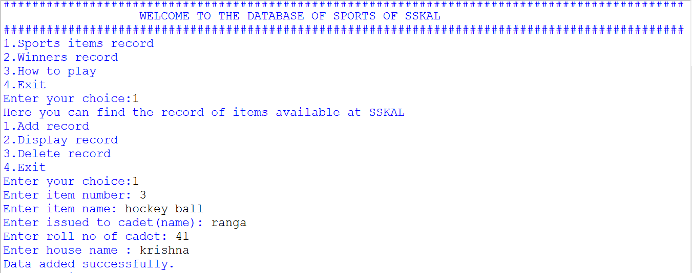

**2. IF THE USER OPTS CHOICE 2 IN 1.**

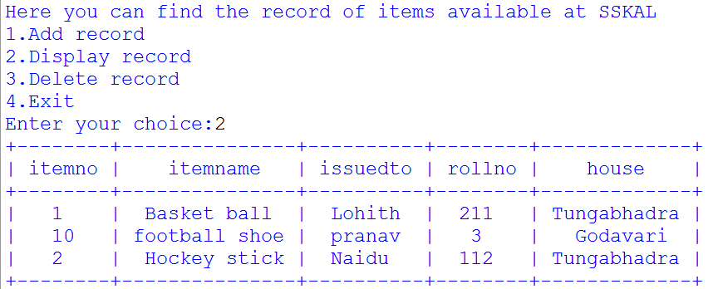

**3. IF THE USER OPTS CHOICE 3 IN 1.**

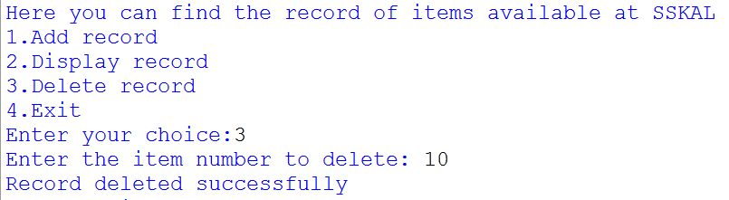

**4. IF THE USER OPTS CHOICE 4 IN 1.**

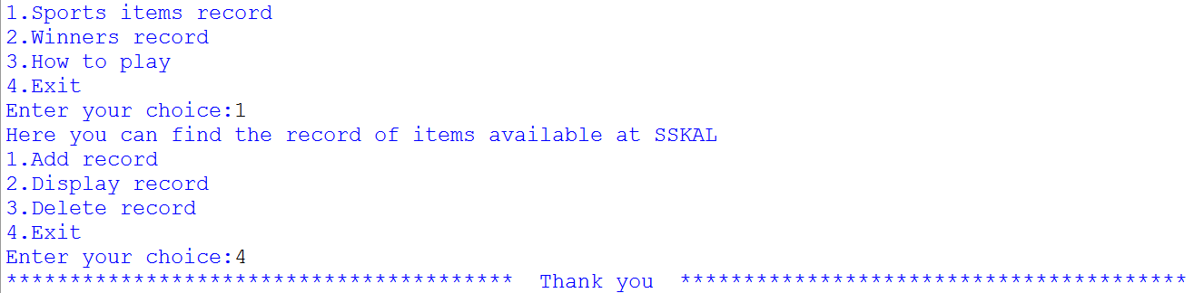

**5. IF THE USER OPTS CHOICE 1 IN 2.**

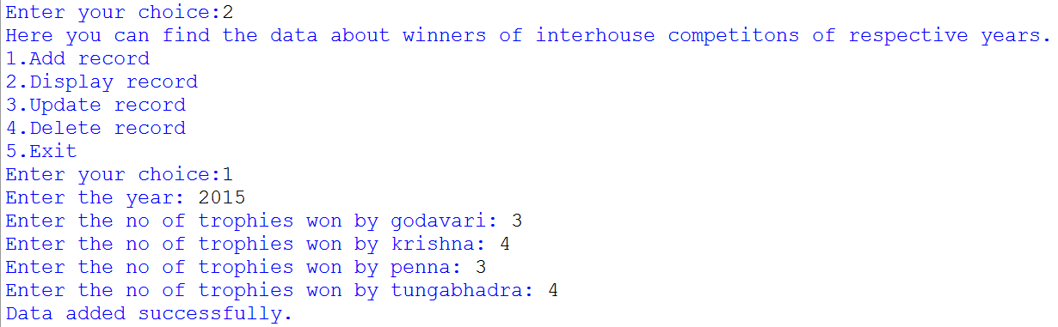

**6. IF THE USER OPTS CHOICE 2 IN 2.**

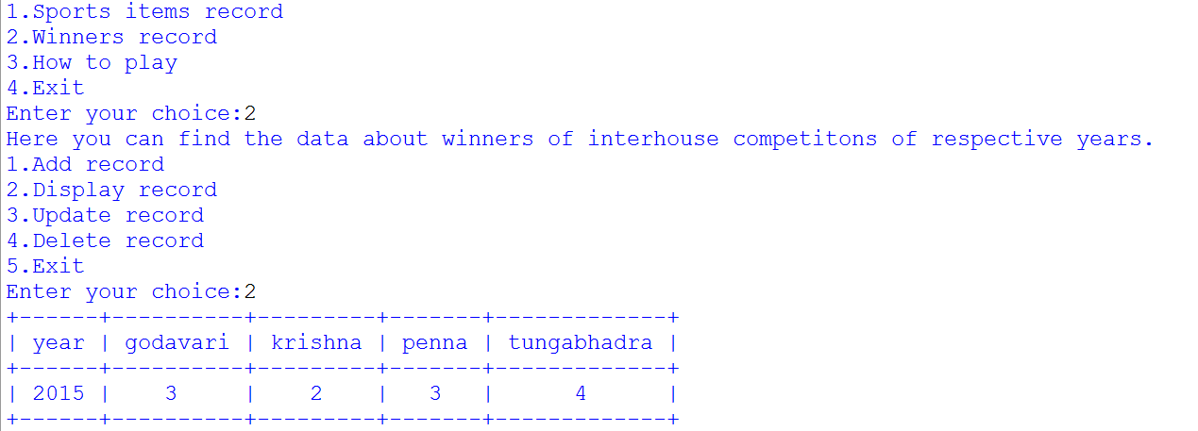

**7. IF THE USER OPTS CHOICE 3 IN 2.**

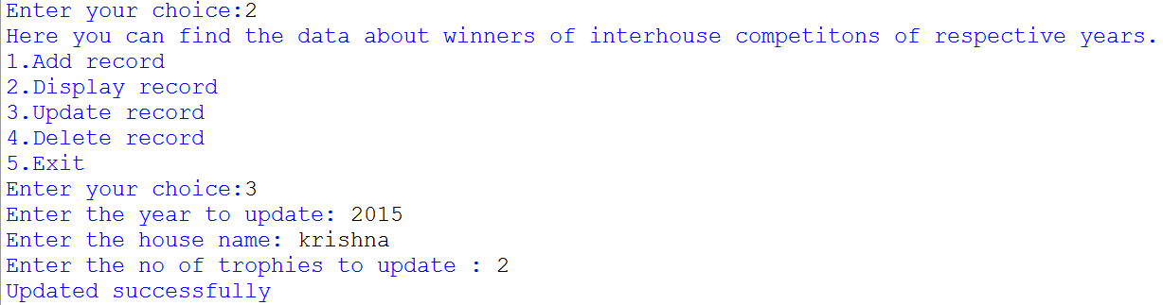

**8. IF THE USER OPTS CHOICE 4 IN 2.**

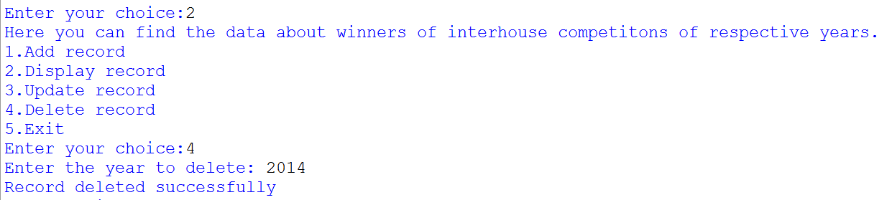

**9. IF THE USER OPTS CHOICE 5 IN 2.**

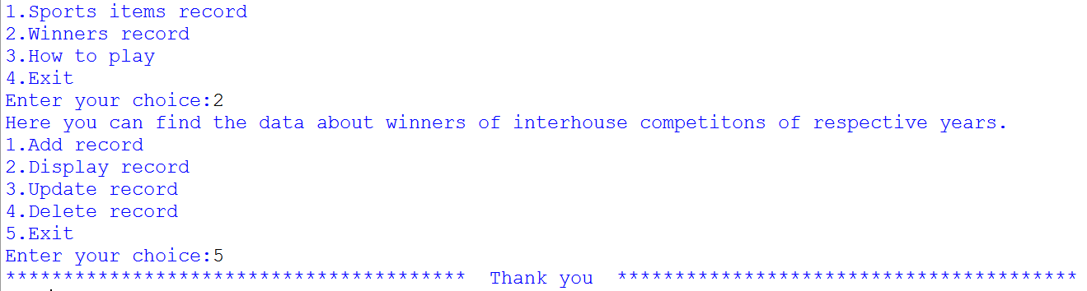

**10. IF THE USER OPTS CHOICE 1 IN 3.**

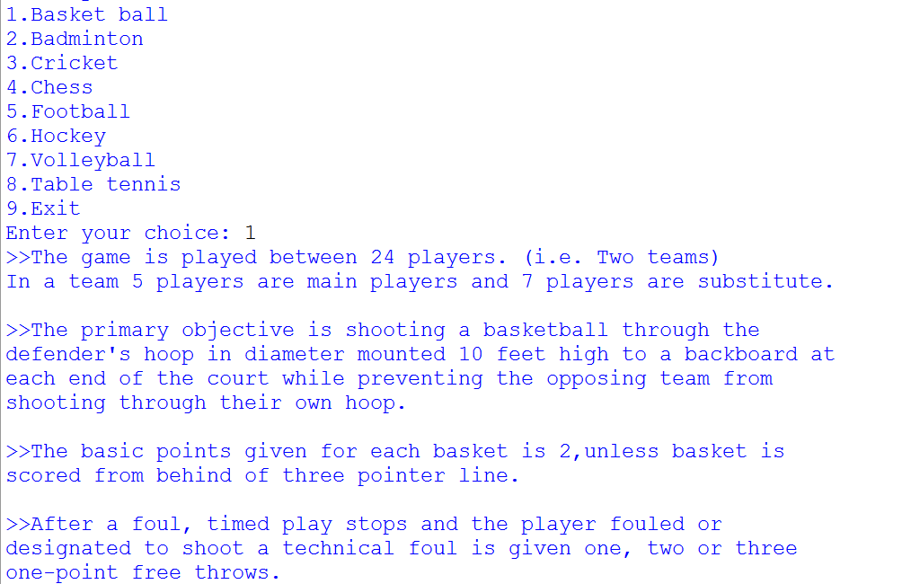

**11. IF THE USER OPTS CHOICE 2 IN 3.**

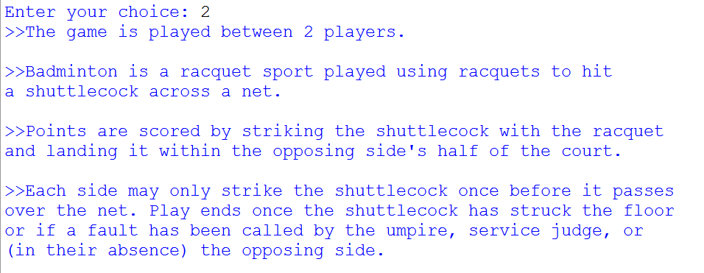

**12. IF THE USER OPTS CHOICE 3 IN 3.**

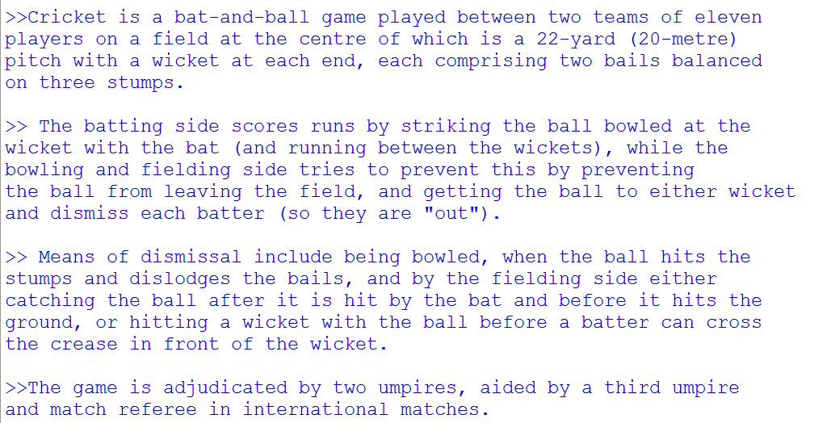

**13. IF THE USER OPTS CHOICE 4 IN 3.**

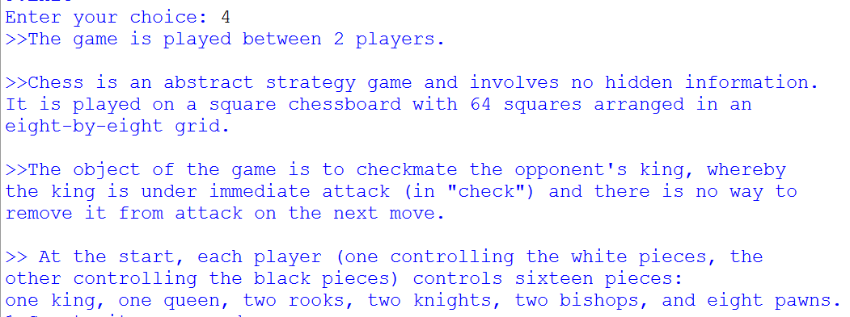

**14. IF THE USER OPTS CHOICE 5 IN 3.**

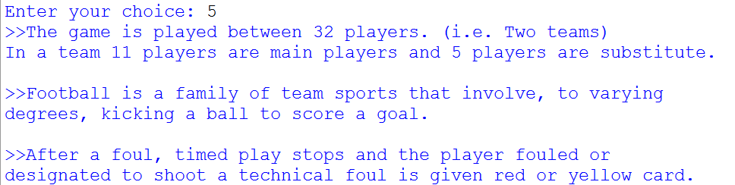

**15. IF THE USER OPTS CHOICE 6 IN 3.**

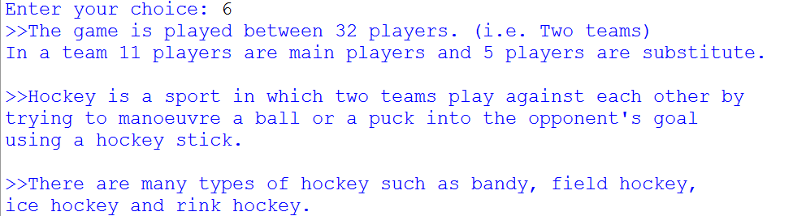

**16. IF THE USER OPTS CHOICE 7 IN 3.**

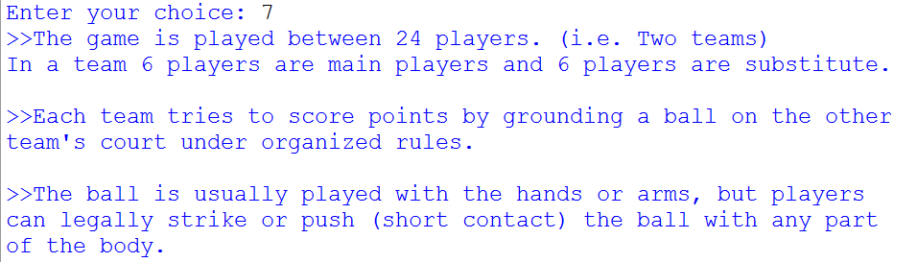

**17. IF THE USER OPTS CHOICE 8 IN 3.**

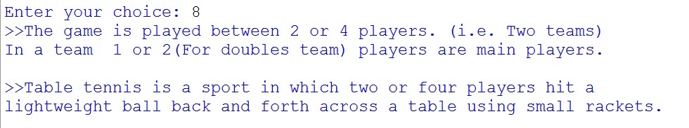

**18. IF THE USER OPTS CHOICE 9 IN 3.**

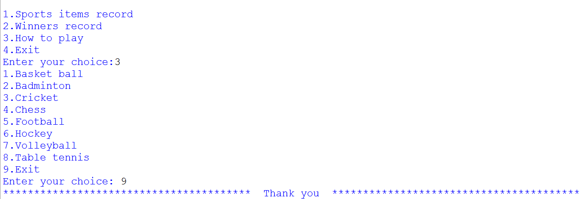

**19. IF THE USER OPTS CHOICE 4.**

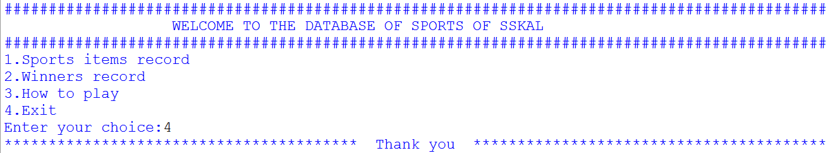

** LIMITATIONS**

1. **THE USER CANNOT KNOW THE RECEIVED INFORMATION.**
2. **THE DATA ABOUT DAMAGED ITEM IS NOT SHOWN.**

 **BIBLIOGRAPHY**

**COMPUTER SCIENCE WITH PYTHON**

**SUMITA ARORA**

## 

## A Project Report On

***“****SSKAL SPORTS database”*

### Submitted by:

### K BABLA NAIK

### Roll no.96 Class: XII

### CBSE Roll no:

**Under the Guidance of**

Mr. Anoop

PGT (Computer Science)

Department of Computer science.

**SAINIK SCHOOL KALIKIRI**

****C E R T I F I C A T E

This is to certify that **cdt. K BABLA NAIK,** Roll No. 96 of Class XII has prepared the report on the Project entitled **“SSKAL SPORTS DATABASE”**. The report is the result of his efforts & endeavors. The report is found worthy of acceptance as final project report for the subject Computer Science of Class XII. He has prepared the report under my guidance.

(Mr. Anoop)

PGT (Computer Science)

**D E C L A R A T I O N**

I hereby declare that the project work entitled “**SSKAL SPORTS DATABASE**”, submitted to Department of **Computer Science**, SAINIK SCHOOL KALIKIRI is **prepared** by **me**. All the **coding** is the result of my **personal efforts.**

cdt. K BABLA NAIK

Roll No. 96

Class XII

.

****A **C K N O W L E D G E M E N T**

I would like to express a deep sense of thanks & gratitude to my **project guide Mr. Anoop** Sir for guiding me immensely through the course of the project. He always evinced keen interest in my work. His constructive advice &**constant motivation** have been responsible for the **successful** completion of this project.

My sincere thanks goes to **Capt.(IN). Vikranth kishore,** our **principal** sir, for his co-ordination in extending every **possible support** for the completion of this project.

I also thanks to my **parents** for their **motivation & support**. I must thanks to my **classmates** for their timely help & support for **compilation** of this **project**.

**Last but not the least; I would like to thank all those who had helped directly or indirectly towards the completion of this project.**

Cdt. K BABLA NAIK

Roll No. 96, Class XII



CONTENTS



1. WORKING DESCRIPTION. . . . . . . . . . . . .

2. CODING. . . . . . . . . . . . . . . . . . . . . . . . . . .

3. OUTPUT SCREENS. . . . . . . . . . . . . . . . . . .

4. LIMITATIONS . . . . . . . . . . . . . . . . . . . . . .

5. BIBLIOGRAPHY . . . . . . . . . . . . . . . . . . . . .

**WORKING DESCRIPTION**



This program is designed for maintaining the record of the Sports data.

1. TO VIEW SPORTS ITEMS AND ISSUED ITEM DETAILS.

AND TO ADD OR DELETE AN ITEM IN THE RECORD.

1. TO VIEW THE WINNERS DATA AND EDIT DATA.
2. TO KNOW ABOUT HOW TO PLAY GAME .
3. TO EXIT THE GAME

**Code of the program**

import mysql.connector as m

from prettytable import PrettyTable

con = m.connect (host = 'localhost', user = 'root', password = 'student')

cur = con.cursor()

cur.execute('create database if not exists sports')

cur.execute('use sports')

cur.execute('create table if not exists issue(itemno varchar(10) primary key,itemname varchar(150),issuedto varchar(50),rollno int(20),house varchar(30))')

cur.execute('create table if not exists winners(year int(10) primary key,godavari int(10),krishna int(10),penna int(10),tungabhadra int(10))')

con.commit()

print('#'*95)

print(' WELCOME TO THE DATABASE OF SPORTS OF SSKAL ')

print('#'*95)

while True:

print('1.Sports items record')

print('2.Winners record')

print('3.How to play')

print('4.Exit')

choice = int(input('Enter your choice:'))

if choice == 1:

print('Here you can find the record of items available at SSKAL')

print('1.Add record')

print('2.Display record')

print('3.Delete record')

print('4.Exit')

choice = int(input('Enter your choice:'))

if choice == 1:

itemno = input('Enter item number: ')

itemname = input('Enter item name: ')

issuedto = input('Enter issued to cadet(name): ')

rollno = int(input('Enter roll no of cadet: '))

house = input('Enter house name : ')

query0 = "insert into issue values('{}','{}','{}',{},'{}')".format(itemno,itemname,issuedto,rollno,house)

try:

cur.execute(query0)

con.commit()

print('Data added successfully.')

except m.Error as err:

print('The following error occured')

print(err)

elif choice == 2:

query1 = "select * from issue "

try:

cur.execute(query1)

result = cur.fetchall()

t = PrettyTable(['itemno','itemname','issuedto','rollno','house'])

for i in result:

t.add_row(i)

print(t)

except m.Error as err:

print('The following error occured.')

print(err)

elif choice == 3:

delete = int(input('Enter the item number to delete: '))

query5 = "delete from issue where itemno = {}".format(delete)

cur.execute(query5)

con.commit()

print('Record deleted successfully')

elif choice == 4:

con.close()

print('*'*40,' Thank you ','*'*40)

break

else:

print('Invalid choice!!!')

elif choice == 2:

print('Here you can find the data about winners of interhouse competitons of respective years.')

print('1.Add record')

print('2.Display record')

print('3.Update record')

print('4.Delete record')

print('5.Exit')

choice = int(input('Enter your choice:'))

if choice == 1:

year = int(input('Enter the year: '))

godavari = int(input('Enter the no of trophies won by godavari: '))

krishna = int(input('Enter the no of trophies won by krishna: '))

penna = int(input('Enter the no of trophies won by penna: '))

tungabhadra = int(input('Enter the no of trophies won by tungabhadra: '))

query0 = "insert into winners values({},{},{},{},{})".format(year,godavari,krishna,penna,tungabhadra)

try:

cur.execute(query0)

con.commit()

print('Data added successfully.')

except m.Error as err:

print('The following error occured')

print(err)

elif choice == 2:

query1 = "select * from winners "

try:

cur.execute(query1)

result = cur.fetchall()

t = PrettyTable(['year','godavari','krishna','penna','tungabhadra'])

for i in result:

t.add_row(i)

print(t)

except m.Error as err:

print('The following error occured.')

print(err)

elif choice == 3:

year = int(input("Enter the year to update: "))

query3 = "select * from winners where year = {}".format(year)

cur.execute(query3)

result = cur.fetchall()

if cur.rowcount == 0:

print('No record found')

else:

house = input('Enter the house name: ')

no_of_trophy = int(input("Enter the no of trophies to update : "))

cur.execute(f"update winners set {house} = {no_of_trophy} where year = {year}")

con.commit()

print('Updated successfully')

elif choice == 4:

delete = int(input('Enter the year to delete: '))

query5 = "delete from winners where year = {}".format(delete)

cur.execute(query5)

con.commit()

print('Record deleted successfully')

elif choice == 5:

con.close()

print('*'*40,' Thank you ','*'*40)

break

else:

print('Invalid choice!!!')

elif choice == 3:

print('1.Basket ball')

print('2.Badminton')

print('3.Cricket')

print('4.Chess')

print('5.Football')

print('6.Hockey')

print('7.Volleyball')

print('8.Table tennis')

print('9.Exit')

choice = int(input('Enter your choice: '))

###1 Basket ball

if choice == 1:

print('''>>The game is played between 24 players. (i.e. Two teams)

In a team 5 players are main players and 7 players are substitute.

>>The primary objective is shooting a basketball through the

defender's hoop in diameter mounted 10 feet high to a backboard at

each end of the court while preventing the opposing team from

shooting through their own hoop.

>>The basic points given for each basket is 2,unless basket is

scored from behind of three pointer line.

>>After a foul, timed play stops and the player fouled or

designated to shoot a technical foul is given one, two or three

one-point free throws.

''')

###2 Badminton

elif choice == 2:

print('''>>The game is played between 2 players.

>>Badminton is a racquet sport played using racquets to hit

a shuttlecock across a net.

>>Points are scored by striking the shuttlecock with the racquet

and landing it within the opposing side's half of the court.

>>Each side may only strike the shuttlecock once before it passes

over the net. Play ends once the shuttlecock has struck the floor

or if a fault has been called by the umpire, service judge, or

(in their absence) the opposing side.

''')

###3 Cricket

elif choice == 3:

print('''>>The game is played between 32 players. (i.e. Two teams)

In a team 11 players are main players and 5 players are substitute.

>>Cricket is a bat-and-ball game played between two teams of eleven

players on a field at the centre of which is a 22-yard (20-metre)

pitch with a wicket at each end, each comprising two bails balanced

on three stumps.

>> The batting side scores runs by striking the ball bowled at the

wicket with the bat (and running between the wickets), while the

bowling and fielding side tries to prevent this by preventing

the ball from leaving the field, and getting the ball to either wicket

and dismiss each batter (so they are "out").

>> Means of dismissal include being bowled, when the ball hits the

stumps and dislodges the bails, and by the fielding side either

catching the ball after it is hit by the bat and before it hits the

ground, or hitting a wicket with the ball before a batter can cross

the crease in front of the wicket.

>>The game is adjudicated by two umpires, aided by a third umpire

and match referee in international matches.''')

###4 Chess

elif choice == 4:

print('''>>The game is played between 2 players.

>>Chess is an abstract strategy game and involves no hidden information.

It is played on a square chessboard with 64 squares arranged in an

eight-by-eight grid.

>>The object of the game is to checkmate the opponent's king, whereby

the king is under immediate attack (in "check") and there is no way to

remove it from attack on the next move.

>> At the start, each player (one controlling the white pieces, the

other controlling the black pieces) controls sixteen pieces:

one king, one queen, two rooks, two knights, two bishops, and eight pawns. ''')

###5 Football

elif choice == 5:

print('''>>The game is played between 32 players. (i.e. Two teams)

In a team 11 players are main players and 5 players are substitute.

>>Football is a family of team sports that involve, to varying

degrees, kicking a ball to score a goal.

>>After a foul, timed play stops and the player fouled or

designated to shoot a technical foul is given red or yellow card.''')

###6 Hockey

elif choice == 6:

print('''>>The game is played between 32 players. (i.e. Two teams)

In a team 11 players are main players and 5 players are substitute.

>>Hockey is a sport in which two teams play against each other by

trying to manoeuvre a ball or a puck into the opponent's goal

using a hockey stick.

>>There are many types of hockey such as bandy, field hockey,

ice hockey and rink hockey.''')

###7 Volleyball

elif choice == 7:

print('''>>The game is played between 24 players. (i.e. Two teams)

In a team 6 players are main players and 6 players are substitute.

>>Each team tries to score points by grounding a ball on the other

team's court under organized rules.

>>The ball is usually played with the hands or arms, but players

can legally strike or push (short contact) the ball with any part

of the body.''')

###8 Table tennis

elif choice == 8:

print('''>>The game is played between 2 or 4 players. (i.e. Two teams)

In a team 1 or 2(For doubles team) players are main players.

>>Table tennis is a sport in which two or four players hit a

lightweight ball back and forth across a table using small rackets.

''')

elif choice == 9:

print('*'*40,' Thank you ','*'*40)

break

elif choice == 4:

print('*'*40,' Thank you ','*'*40)

break

else:

print('Invalid choice!!!')

**___________________________END OF THE CODE___________________________________**

**OUTPUT OF THE PROGRAM**



**1. OPENING VIEW OF THE PROGRAM.AND IF USER OPTS OPTION 1.**



**2. IF THE USER OPTS CHOICE 2 IN 1.**



**3. IF THE USER OPTS CHOICE 3 IN 1.**



**4. IF THE USER OPTS CHOICE 4 IN 1.**



**5. IF THE USER OPTS CHOICE 1 IN 2.**



**6. IF THE USER OPTS CHOICE 2 IN 2.**



**7. IF THE USER OPTS CHOICE 3 IN 2.**



**8. IF THE USER OPTS CHOICE 4 IN 2.**



**9. IF THE USER OPTS CHOICE 5 IN 2.**



**10. IF THE USER OPTS CHOICE 1 IN 3.**



**11. IF THE USER OPTS CHOICE 2 IN 3.**



**12. IF THE USER OPTS CHOICE 3 IN 3.**



**13. IF THE USER OPTS CHOICE 4 IN 3.**



**14. IF THE USER OPTS CHOICE 5 IN 3.**



**15. IF THE USER OPTS CHOICE 6 IN 3.**



**16. IF THE USER OPTS CHOICE 7 IN 3.**



**17. IF THE USER OPTS CHOICE 8 IN 3.**



**18. IF THE USER OPTS CHOICE 9 IN 3.**



**19. IF THE USER OPTS CHOICE 4.**



** LIMITATIONS**

1. **THE USER CANNOT KNOW THE RECEIVED INFORMATION.**
2. **THE DATA ABOUT DAMAGED ITEM IS NOT SHOWN.**

 **BIBLIOGRAPHY**

**COMPUTER SCIENCE WITH PYTHON**

**SUMITA ARORA**

## 

## A Project Report On

***“****SSKAL SPORTS database”*

### Submitted by:

### AKASH KUMAR

### Roll no.86 Class: XII

### CBSE Roll no:

**Under the Guidance of**

Mr. Anoop

PGT (Computer Science)

Department of Computer science.

**SAINIK SCHOOL KALIKIRI**

****C E R T I F I C A T E

This is to certify that **cdt. AKASH KUMAR,** Roll No. 86 of Class XII has prepared the report on the Project entitled **“SSKAL SPORTS DATABASE”**. The report is the result of his efforts & endeavors. The report is found worthy of acceptance as final project report for the subject Computer Science of Class XII. He has prepared the report under my guidance.

(Mr. Anoop)

PGT (Computer Science)

**D E C L A R A T I O N**

I hereby declare that the project work entitled “**SSKAL SPORTS DATABASE**”, submitted to Department of **Computer Science**, SAINIK SCHOOL KALIKIRI is **prepared** by **me**. All the **coding** is the result of my **personal efforts.**

cdt. AKASH KUMAR

Roll No. 86

Class XII

.

****A **C K N O W L E D G E M E N T**

I would like to express a deep sense of thanks & gratitude to my **project guide Mr. Anoop** Sir for guiding me immensely through the course of the project. He always evinced keen interest in my work. His constructive advice &**constant motivation** have been responsible for the **successful** completion of this project.

My sincere thanks goes to **Capt.(IN). Vikranth kishore,** our **principal** sir, for his co-ordination in extending every **possible support** for the completion of this project.

I also thanks to my **parents** for their **motivation & support**. I must thanks to my **classmates** for their timely help & support for **compilation** of this **project**.

**Last but not the least; I would like to thank all those who had helped directly or indirectly towards the completion of this project.**

Cdt. AKASH KUMAR

Roll No. 211, Class XII



CONTENTS



1. WORKING DESCRIPTION. . . . . . . . . . . . .

2. CODING. . . . . . . . . . . . . . . . . . . . . . . . . . .

3. OUTPUT SCREENS. . . . . . . . . . . . . . . . . . .

4. LIMITATIONS . . . . . . . . . . . . . . . . . . . . . .

5. BIBLIOGRAPHY . . . . . . . . . . . . . . . . . . . . .

**WORKING DESCRIPTION**



This program is designed for maintaining the record of the Sports data.

1. TO VIEW SPORTS ITEMS AND ISSUED ITEM DETAILS.

AND TO ADD OR DELETE AN ITEM IN THE RECORD.

1. TO VIEW THE WINNERS DATA AND EDIT DATA.
2. TO KNOW ABOUT HOW TO PLAY GAME .
3. TO EXIT THE GAME

**Code of the program**

import mysql.connector as m

from prettytable import PrettyTable

con = m.connect (host = 'localhost', user = 'root', password = 'student')

cur = con.cursor()

cur.execute('create database if not exists sports')

cur.execute('use sports')

cur.execute('create table if not exists issue(itemno varchar(10) primary key,itemname varchar(150),issuedto varchar(50),rollno int(20),house varchar(30))')

cur.execute('create table if not exists winners(year int(10) primary key,godavari int(10),krishna int(10),penna int(10),tungabhadra int(10))')

con.commit()

print('#'*95)

print(' WELCOME TO THE DATABASE OF SPORTS OF SSKAL ')

print('#'*95)

while True:

print('1.Sports items record')

print('2.Winners record')

print('3.How to play')

print('4.Exit')

choice = int(input('Enter your choice:'))

if choice == 1:

print('Here you can find the record of items available at SSKAL')

print('1.Add record')

print('2.Display record')

print('3.Delete record')

print('4.Exit')

choice = int(input('Enter your choice:'))

if choice == 1:

itemno = input('Enter item number: ')

itemname = input('Enter item name: ')

issuedto = input('Enter issued to cadet(name): ')

rollno = int(input('Enter roll no of cadet: '))

house = input('Enter house name : ')

query0 = "insert into issue values('{}','{}','{}',{},'{}')".format(itemno,itemname,issuedto,rollno,house)

try:

cur.execute(query0)

con.commit()

print('Data added successfully.')

except m.Error as err:

print('The following error occured')

print(err)

elif choice == 2:

query1 = "select * from issue "

try:

cur.execute(query1)

result = cur.fetchall()

t = PrettyTable(['itemno','itemname','issuedto','rollno','house'])

for i in result:

t.add_row(i)

print(t)

except m.Error as err:

print('The following error occured.')

print(err)

elif choice == 3:

delete = int(input('Enter the item number to delete: '))

query5 = "delete from issue where itemno = {}".format(delete)

cur.execute(query5)

con.commit()

print('Record deleted successfully')

elif choice == 4:

con.close()

print('*'*40,' Thank you ','*'*40)

break

else:

print('Invalid choice!!!')

elif choice == 2:

print('Here you can find the data about winners of interhouse competitons of respective years.')

print('1.Add record')

print('2.Display record')

print('3.Update record')

print('4.Delete record')

print('5.Exit')

choice = int(input('Enter your choice:'))

if choice == 1:

year = int(input('Enter the year: '))

godavari = int(input('Enter the no of trophies won by godavari: '))

krishna = int(input('Enter the no of trophies won by krishna: '))

penna = int(input('Enter the no of trophies won by penna: '))

tungabhadra = int(input('Enter the no of trophies won by tungabhadra: '))

query0 = "insert into winners values({},{},{},{},{})".format(year,godavari,krishna,penna,tungabhadra)

try:

cur.execute(query0)

con.commit()

print('Data added successfully.')

except m.Error as err:

print('The following error occured')

print(err)

elif choice == 2:

query1 = "select * from winners "

try:

cur.execute(query1)

result = cur.fetchall()

t = PrettyTable(['year','godavari','krishna','penna','tungabhadra'])

for i in result:

t.add_row(i)

print(t)

except m.Error as err:

print('The following error occured.')

print(err)

elif choice == 3:

year = int(input("Enter the year to update: "))

query3 = "select * from winners where year = {}".format(year)

cur.execute(query3)

result = cur.fetchall()

if cur.rowcount == 0:

print('No record found')

else:

house = input('Enter the house name: ')

no_of_trophy = int(input("Enter the no of trophies to update : "))

cur.execute(f"update winners set {house} = {no_of_trophy} where year = {year}")

con.commit()

print('Updated successfully')

elif choice == 4:

delete = int(input('Enter the year to delete: '))

query5 = "delete from winners where year = {}".format(delete)

cur.execute(query5)

con.commit()

print('Record deleted successfully')

elif choice == 5:

con.close()

print('*'*40,' Thank you ','*'*40)

break

else:

print('Invalid choice!!!')

elif choice == 3:

print('1.Basket ball')

print('2.Badminton')

print('3.Cricket')

print('4.Chess')

print('5.Football')

print('6.Hockey')

print('7.Volleyball')

print('8.Table tennis')

print('9.Exit')

choice = int(input('Enter your choice: '))

###1 Basket ball

if choice == 1:

print('''>>The game is played between 24 players. (i.e. Two teams)

In a team 5 players are main players and 7 players are substitute.

>>The primary objective is shooting a basketball through the

defender's hoop in diameter mounted 10 feet high to a backboard at

each end of the court while preventing the opposing team from

shooting through their own hoop.

>>The basic points given for each basket is 2,unless basket is

scored from behind of three pointer line.

>>After a foul, timed play stops and the player fouled or

designated to shoot a technical foul is given one, two or three

one-point free throws.

''')

###2 Badminton

elif choice == 2:

print('''>>The game is played between 2 players.

>>Badminton is a racquet sport played using racquets to hit

a shuttlecock across a net.

>>Points are scored by striking the shuttlecock with the racquet

and landing it within the opposing side's half of the court.

>>Each side may only strike the shuttlecock once before it passes

over the net. Play ends once the shuttlecock has struck the floor

or if a fault has been called by the umpire, service judge, or

(in their absence) the opposing side.

''')

###3 Cricket

elif choice == 3:

print('''>>The game is played between 32 players. (i.e. Two teams)

In a team 11 players are main players and 5 players are substitute.

>>Cricket is a bat-and-ball game played between two teams of eleven

players on a field at the centre of which is a 22-yard (20-metre)

pitch with a wicket at each end, each comprising two bails balanced

on three stumps.

>> The batting side scores runs by striking the ball bowled at the

wicket with the bat (and running between the wickets), while the

bowling and fielding side tries to prevent this by preventing

the ball from leaving the field, and getting the ball to either wicket

and dismiss each batter (so they are "out").

>> Means of dismissal include being bowled, when the ball hits the

stumps and dislodges the bails, and by the fielding side either

catching the ball after it is hit by the bat and before it hits the

ground, or hitting a wicket with the ball before a batter can cross

the crease in front of the wicket.

>>The game is adjudicated by two umpires, aided by a third umpire

and match referee in international matches.''')

###4 Chess

elif choice == 4:

print('''>>The game is played between 2 players.

>>Chess is an abstract strategy game and involves no hidden information.

It is played on a square chessboard with 64 squares arranged in an

eight-by-eight grid.

>>The object of the game is to checkmate the opponent's king, whereby

the king is under immediate attack (in "check") and there is no way to

remove it from attack on the next move.

>> At the start, each player (one controlling the white pieces, the

other controlling the black pieces) controls sixteen pieces:

one king, one queen, two rooks, two knights, two bishops, and eight pawns. ''')

###5 Football

elif choice == 5:

print('''>>The game is played between 32 players. (i.e. Two teams)

In a team 11 players are main players and 5 players are substitute.

>>Football is a family of team sports that involve, to varying

degrees, kicking a ball to score a goal.

>>After a foul, timed play stops and the player fouled or

designated to shoot a technical foul is given red or yellow card.''')

###6 Hockey

elif choice == 6:

print('''>>The game is played between 32 players. (i.e. Two teams)

In a team 11 players are main players and 5 players are substitute.

>>Hockey is a sport in which two teams play against each other by

trying to manoeuvre a ball or a puck into the opponent's goal

using a hockey stick.

>>There are many types of hockey such as bandy, field hockey,

ice hockey and rink hockey.''')

###7 Volleyball

elif choice == 7:

print('''>>The game is played between 24 players. (i.e. Two teams)

In a team 6 players are main players and 6 players are substitute.

>>Each team tries to score points by grounding a ball on the other

team's court under organized rules.

>>The ball is usually played with the hands or arms, but players

can legally strike or push (short contact) the ball with any part

of the body.''')

###8 Table tennis

elif choice == 8:

print('''>>The game is played between 2 or 4 players. (i.e. Two teams)

In a team 1 or 2(For doubles team) players are main players.

>>Table tennis is a sport in which two or four players hit a

lightweight ball back and forth across a table using small rackets.

''')

elif choice == 9:

print('*'*40,' Thank you ','*'*40)

break

elif choice == 4:

print('*'*40,' Thank you ','*'*40)

break

else:

print('Invalid choice!!!')

**___________________________END OF THE CODE___________________________________**

**OUTPUT OF THE PROGRAM**



**1. OPENING VIEW OF THE PROGRAM.AND IF USER OPTS OPTION 1.**



**2. IF THE USER OPTS CHOICE 2 IN 1.**



**3. IF THE USER OPTS CHOICE 3 IN 1.**



**4. IF THE USER OPTS CHOICE 4 IN 1.**



**5. IF THE USER OPTS CHOICE 1 IN 2.**



**6. IF THE USER OPTS CHOICE 2 IN 2.**



**7. IF THE USER OPTS CHOICE 3 IN 2.**



**8. IF THE USER OPTS CHOICE 4 IN 2.**



**9. IF THE USER OPTS CHOICE 5 IN 2.**



**10. IF THE USER OPTS CHOICE 1 IN 3.**



**11. IF THE USER OPTS CHOICE 2 IN 3.**



**12. IF THE USER OPTS CHOICE 3 IN 3.**



**13. IF THE USER OPTS CHOICE 4 IN 3.**



**14. IF THE USER OPTS CHOICE 5 IN 3.**



**15. IF THE USER OPTS CHOICE 6 IN 3.**



**16. IF THE USER OPTS CHOICE 7 IN 3.**



**17. IF THE USER OPTS CHOICE 8 IN 3.**



**18. IF THE USER OPTS CHOICE 9 IN 3.**



**19. IF THE USER OPTS CHOICE 4.**



** LIMITATIONS**

1. **THE USER CANNOT KNOW THE RECEIVED INFORMATION.**
2. **THE DATA ABOUT DAMAGED ITEM IS NOT SHOWN.**

 **BIBLIOGRAPHY**

**COMPUTER SCIENCE WITH PYTHON**

**SUMITA ARORA**